**Section 1: Research**

1. **Entry Form:**

User should open an Excel-like entry form:

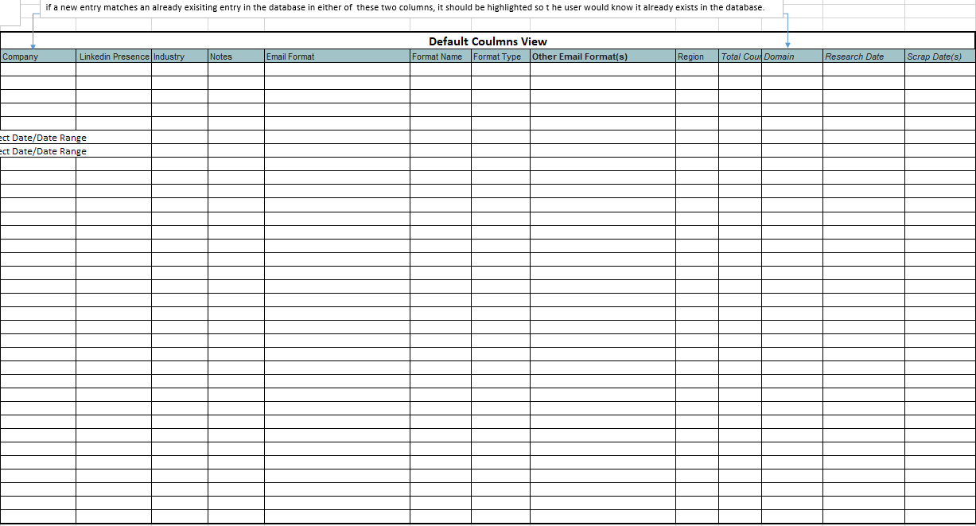

This form will have following Headers:

* Company
* LinkedIn Presence
* Industry
* Notes
* Email Format
* Format Name
* Format Type
* Other Email Format(s)
* Region Total Count
* Domain
* Research Date
* Scrap Date(s) x

The user will populate data against these headers manually:

**Note:** if a new entry matches an already existing entry in the database in either **Company** or **Domain** columns, it should be highlighted so the user would know it already exists in the database.

**Example data:**

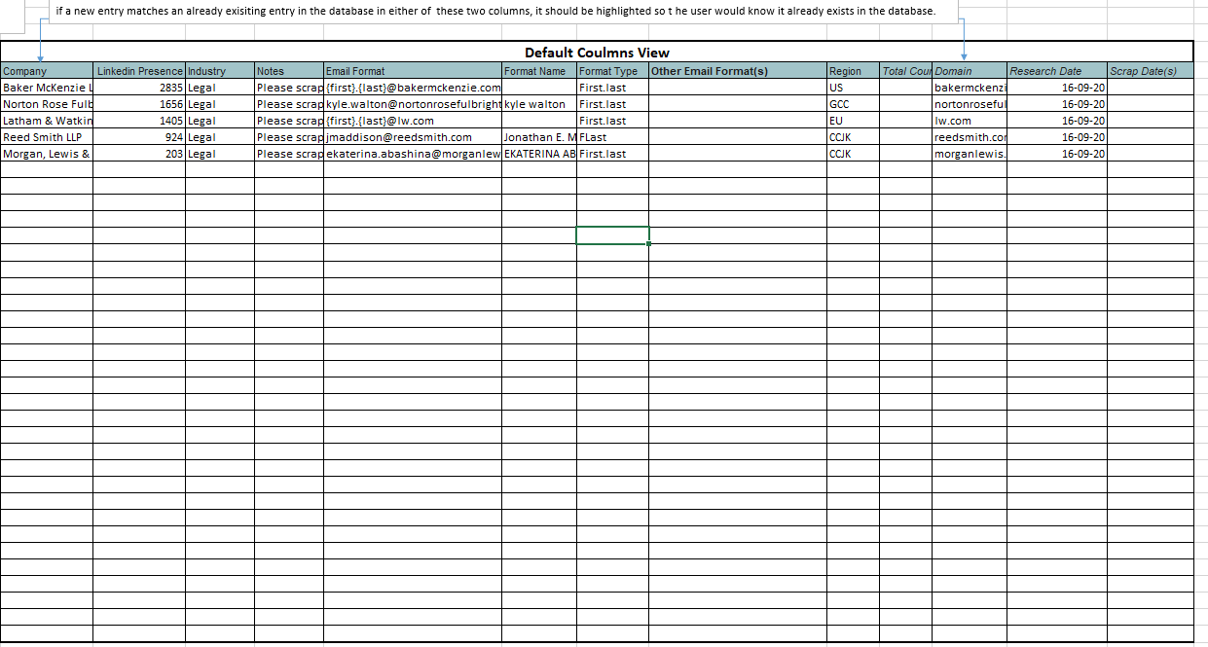

There should be a filter form with a button to upload this data in the database and after that the entry form should become empty:

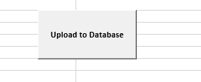

1. **Scraping/Amendment Form:**

After uploading the data in Research form another user will got to scraping form, find the data that was uploaded through Research form using filters like **Research Date**:

**Filters:**

**Note:** User can Select 1 or multiple entries in each filter, multiple filters can be applied at the same time.

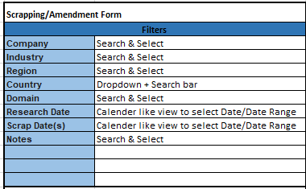

By using a filter, we should be able to find data previously added through Research form:

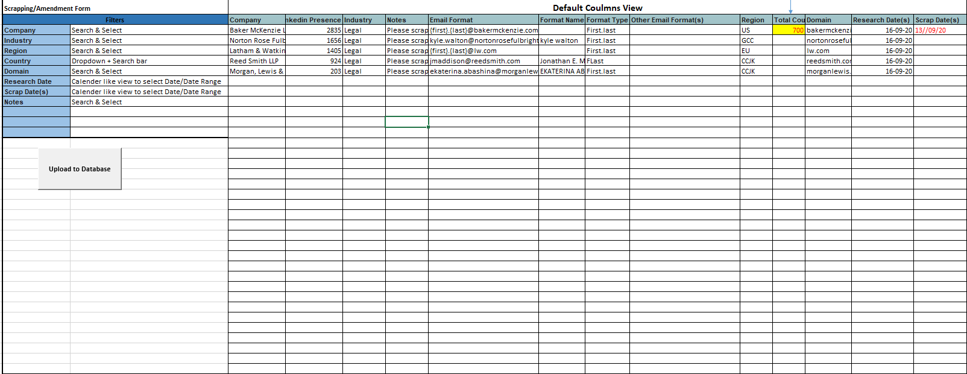

After user has searched the required data, he should be able to select country dropdown from Country filter:



**Total Countries in Country Dropdown Filter:**

UAE, KSA, QA, OM, BH, KW, MA, JO, DZ, EG, KE, LB, LY, NG, ZA, TN, TR, AU, NZ, SG, CN, JP, KR, HK, US, UK, NL, ES, FR, IT, DE, NO, SE, FI, IS, BE, CH, BG, DK, AT, GR, PL, LU

The selected filters from Country Dropdown show as new columns attached with the form:

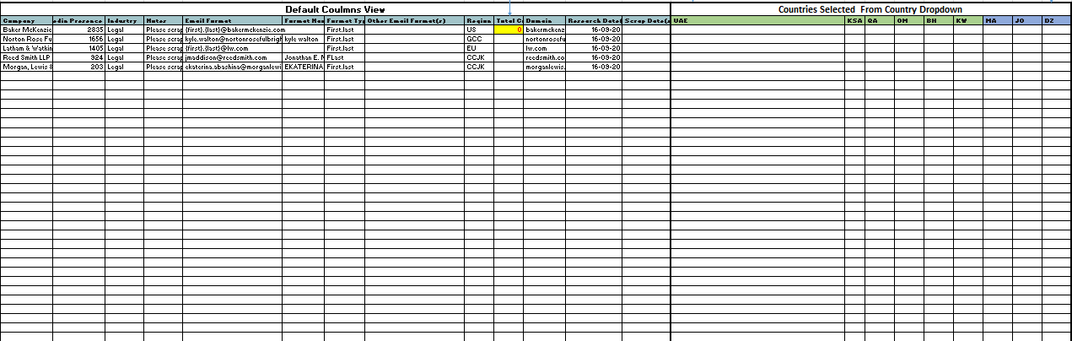As you can see below I have select UAE, KSA, QA OM, BH, KW, MA, JO and DZ from the dropdown:

Once selected the user will fill the numbers in **Country** columns and Sum of each row will be populated (Formula based) in **Total** **Count** Column:

**Note:** If a country column is already filled with data then it should automatically appear in search

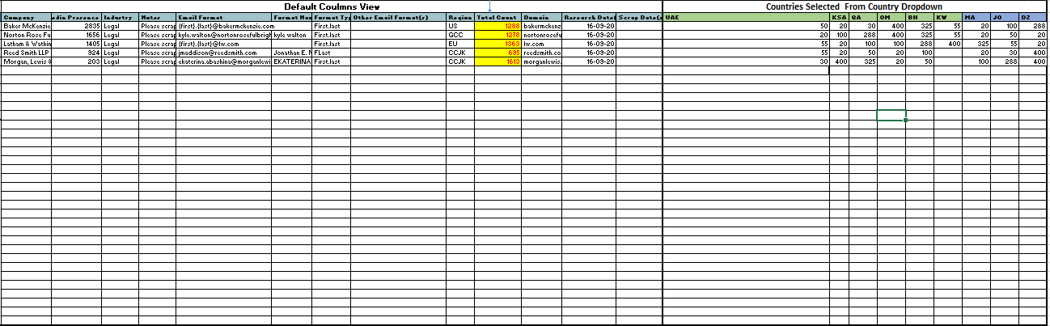

**Scrap Date(s):** When a user adds count in country coulmn, a date for that day should be generated in the Scrap Date Column, however if the user adds count in another country column on another day, another date should be added in the **Scarp date(s)** and the dates in **Scrap Date(s)** column should be separated by a Comma, duplicate dates should not be picked.

**Section 2a:**

1. **Upload CSV Option:**

We should be able to upload our post validation data through a single or a batch of CSV files here:

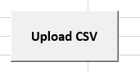

**Note:** A warning popup should appear if the headers of a CSV do not match with the headers of database before the CSV is uploaded in the database and the error containing file should not be uploaded.

e.g:

Aeria Games GmbH-EU-20_08_20

File Headers Do Not Match

1. **Search Form:**

The user should be able to search and View the uploaded data through CSV(s) through A search form using filters.

**Filters:**

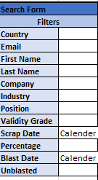

**Form Headers:**



**The view of the data (Search form) should like this**: if I find and filter a “**Company”** let say Covenceand “**Scrap date”** 16-09-20 the Search form should give me this view:

**Note:** Scrap date here should be picked up from the section 1 Scrap Date(s), through Company Name and Country reference**.**

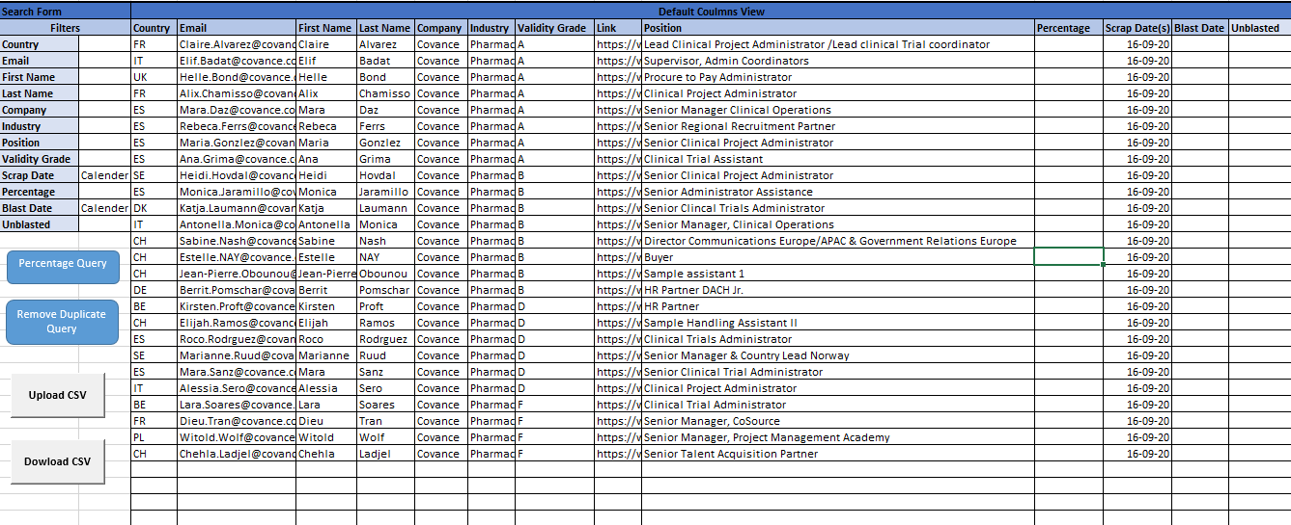

**Note:** We should be able to update our data here, and then click on the upload button and all the changes will be saved in the Database.

e.g: I will add a date in “**Blast Date”** and also update Column **“Unblasted”**

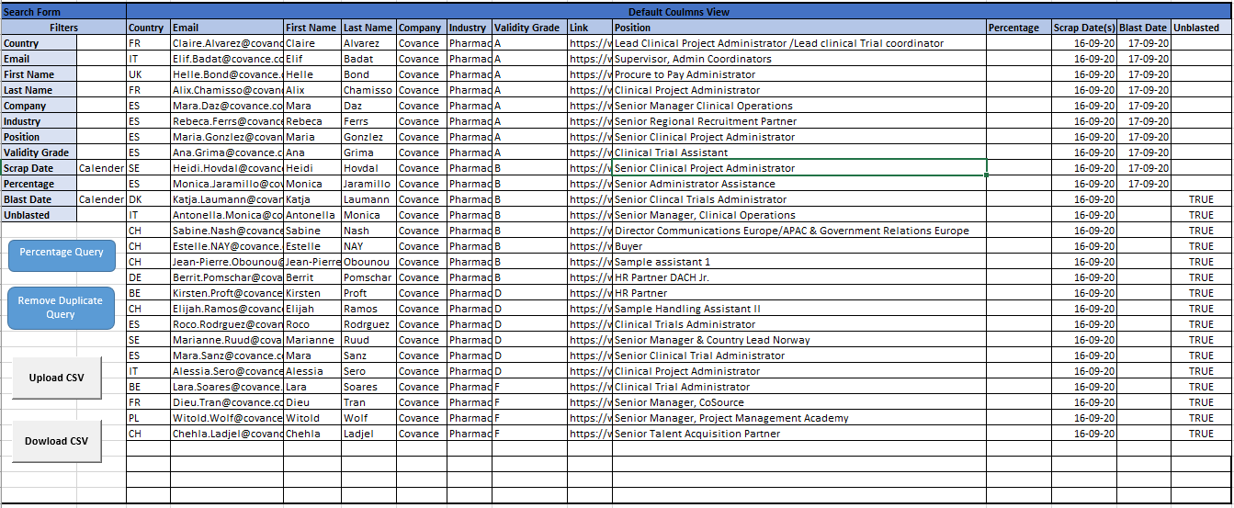

A button should be available to save my changes in Database:

**Save Changes**

**Percentage Query:** We want the “percentage “column to be populated whenever we apply the “Percentage Query” with percentage of available data in the form, for example a sample data has been filled along with its percentage:

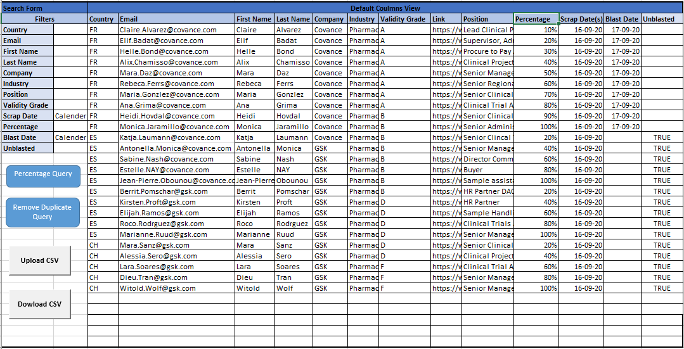

After applying the Percentage query we will use “**Percentage**” Filter to select a percentage of the data:



**Remove Duplicate Query:**

When a user presses Remove Duplicate Query button a popup should appear:

Remove Duplicate Query

Remove Duplicate

Old Data Date Range

Blast List Date range

Remove Duplicate Query Popup

**Old Data Range:** User should be able to select an older date range here e.g. March 2020 to June 2020 (we call it List 1)

**Blast List Date Range:** User should be able to select another date range here e.g. August 1 to August 10 (call it list 2)

Then the user presses Remove **Duplicate button** and the data that is common in both data ranges should be removed from list 2 (Blast list date range)

**Note:** The common column in Both data lists (list 1 and list 2), where the duplicate data is checked is “**Email**” column, but the whole row is being removed from the list 2.

**Download CSV:**

We will then download the data in a CSV by pressing a button:

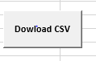

**Note**: A pop should appear when we click download CSV button asking us the purpose of download, it will give us 2 options:

Select the Purpose of Download

If Blast List option is selected, then a date for that day should automatically be populated in the “**Blast Date**” Column against the downloaded data, if the “Other” is selected then CSV should be downloaded without adding any date.

**Section 2b:**

This section uses the same database as section 2a and will be uploaded after we have blasted our emails and we have their results in a CSV file, it will utilize a few extra columns:

User will upload a CSV file through an upload button:

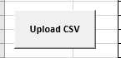

Headers specific to this section:

|  |
| --- |
| **Sent** |
| **Delivered** |
| **Soft Bounce** |
| **Hard Bounce** |
| **Opened** |
| **Unsubscribed** |

Section 2b Headers

Section 2a Headers

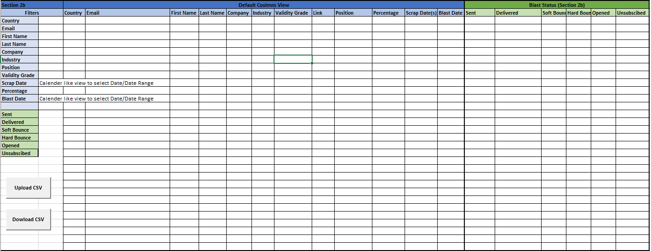

Section 2b Filters

**Note:**  User should be able to use both section 2a &2b filters here.

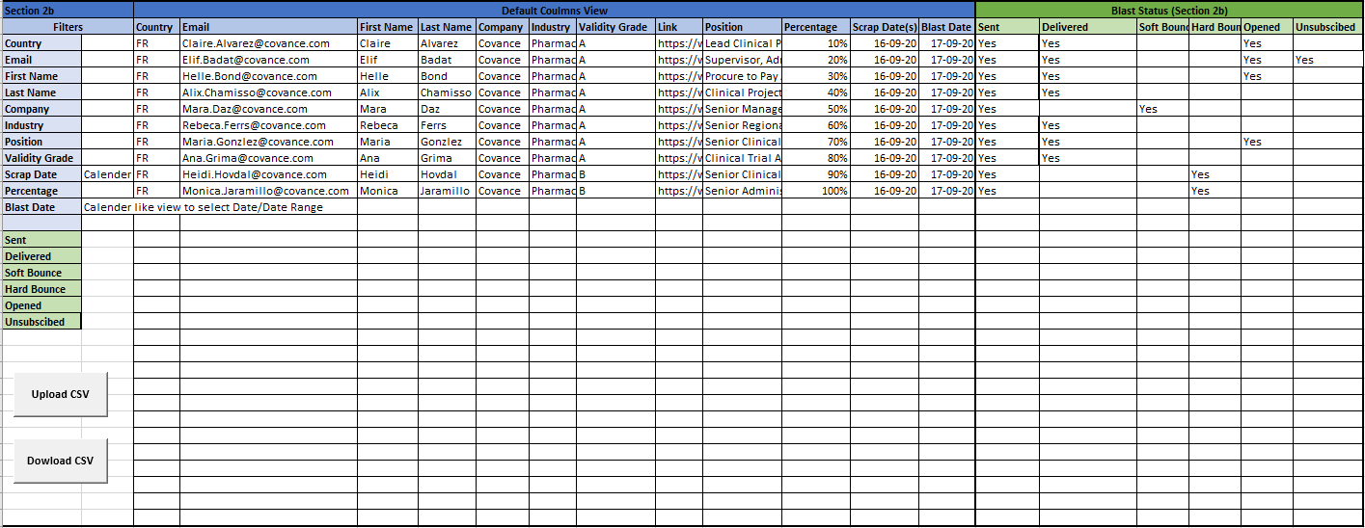I have filled in an example for how section 2b columns should be filled:

**Section 3: Overview**

**Pivot Table view:**

This section has 4 parts:

1. Default Columns View
2. Countries (Selected from Country Dropdown)
3. Validity Grade
4. Blast status (Section 2b)
5. **Default Columns View:**

|  |  |  |  |
| --- | --- | --- | --- |
| **Default Columns View** | | | |
| **Company** | **Industry** | **Scrap Date(s)** | **Blast Date** |

**Filters:**

|  |  |
| --- | --- |
| **Filters** | |
| **Company** | Dropdown |
| **Industry** |  |
| **Scrap Date** | Calendar like view to select Date/Date Range |
| **Blast Date** | Calendar like view to select Date/Date Range |

1. **Countries (Selected from Country Dropdown)**

|  |  |  |  |  |  |
| --- | --- | --- | --- | --- | --- |
| **Countries Selected From Country Filter (Section 2a Data)** | | | | | |
| **KSA** | **QA** | **OM** | **BH** | **KW** | **Total Count** |

**Filter: Country Dropdown**

|  |  |
| --- | --- |
| **Country** |  |

1. **Validity Grade**

|  |  |  |  |
| --- | --- | --- | --- |
| **Validity Grade** | | | |
| **A** | **B** | **D** | **F** |

**Filter:**

|  |  |
| --- | --- |
| **Validity Grade** |  |

1. **Blast status (Section 2b)**

|  |  |  |  |  |  |
| --- | --- | --- | --- | --- | --- |
| **Blast Status (Section 2b)** | | | | | |
| **Sent** | **Delivered** | **Soft Bounce** | **Hard Bounce** | **Opened** | **Unsubscribed** |

**Filters:**

|  |  |
| --- | --- |
| **Sent** |  |
| **Delivered** |  |
| **Soft Bounce** |  |
| **Hard Bounce** |  |
| **Opened** |  |
| **Unsubscribed** |  |

**Overall View:**

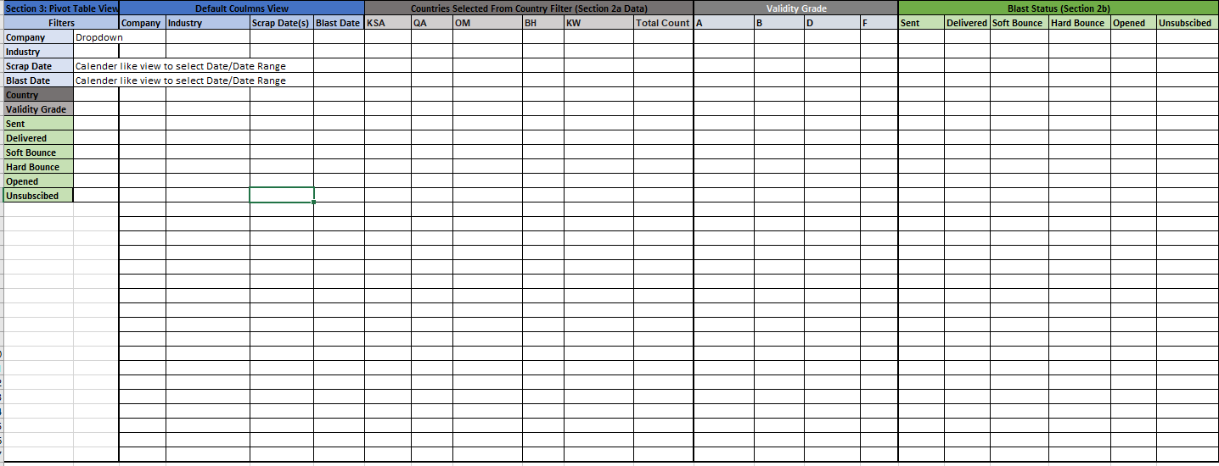

The data in section 3 will be picked up from **Section 2a and 2b,** and converted into a pivot table:

E.g.:

3.

4.

2.

1.

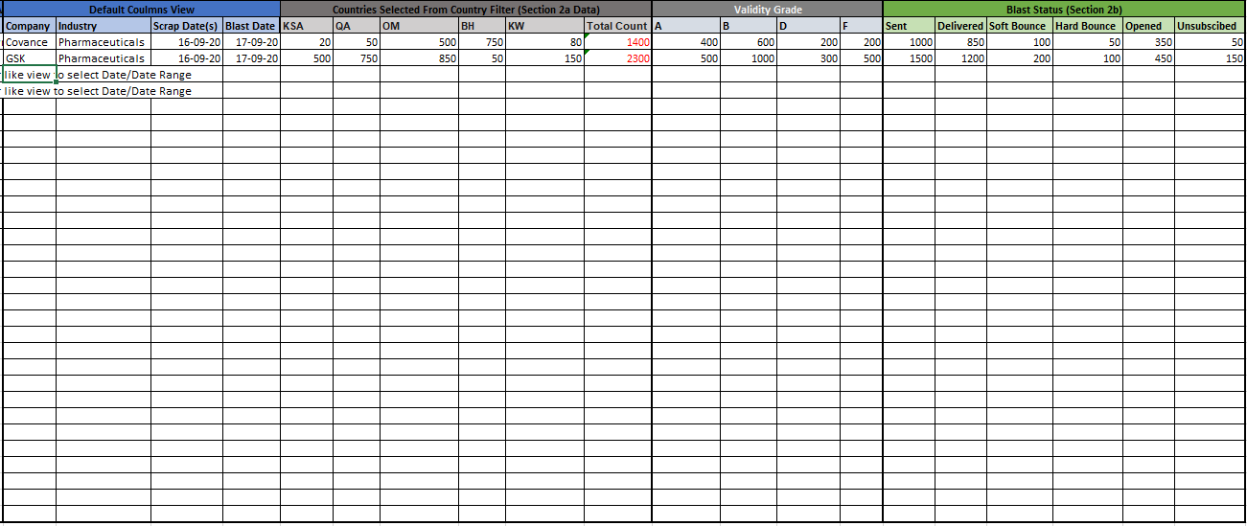

1. This section picks data from section 2a
2. Count of each country against select Companies from section 2a, also formula based **Total Count** as a sum of data shown in individual countries.
3. **Validity Grade:** Count of each Grade A, B, C & D for the selected **Company.**
4. Count of **Blast status** from **Section 2b.**